**Task 9**

**Task description:** To create a kubernetes cluster on any cloud of your preference AWS/Azure and upgrade it to next version.

🡪I did the task in AWS console.

🡪Here, I created three virtual machines (EC2 Instances): mas1, node1, node2.

🡪I followed this configuration:

-Install kubernetes

-Install network

-Install container runtime as Docker.

🡪 Now, connect all the three servers in AWS terminal.

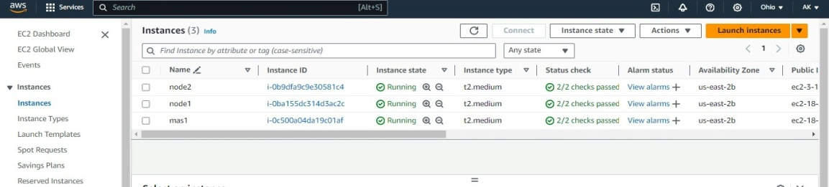

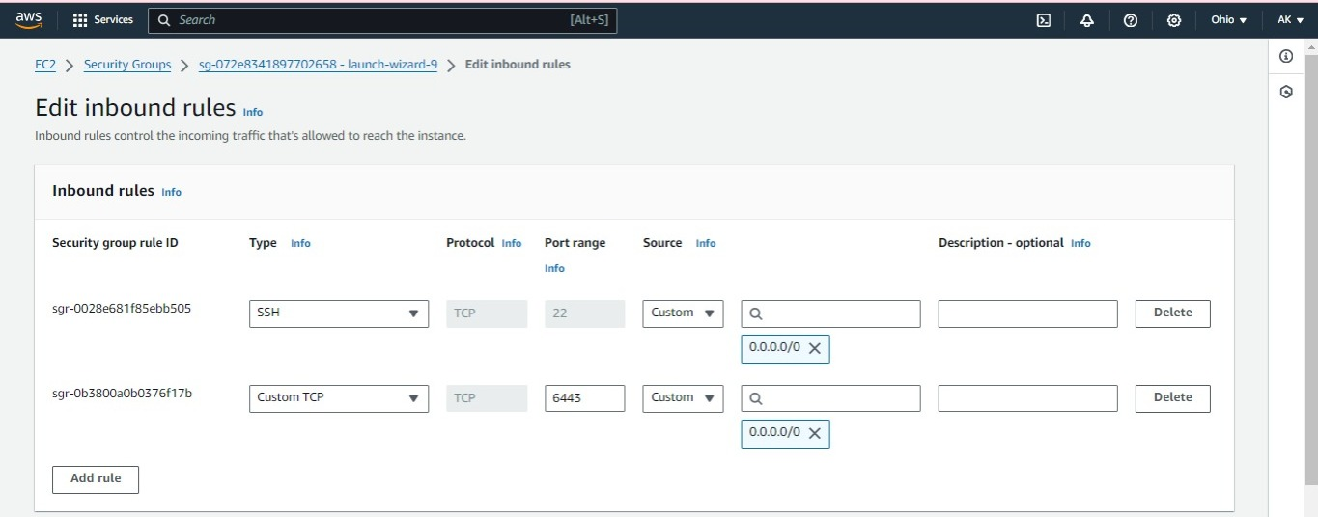

Step 1: Install docker. By using this command we can install,

#yum install docker –y

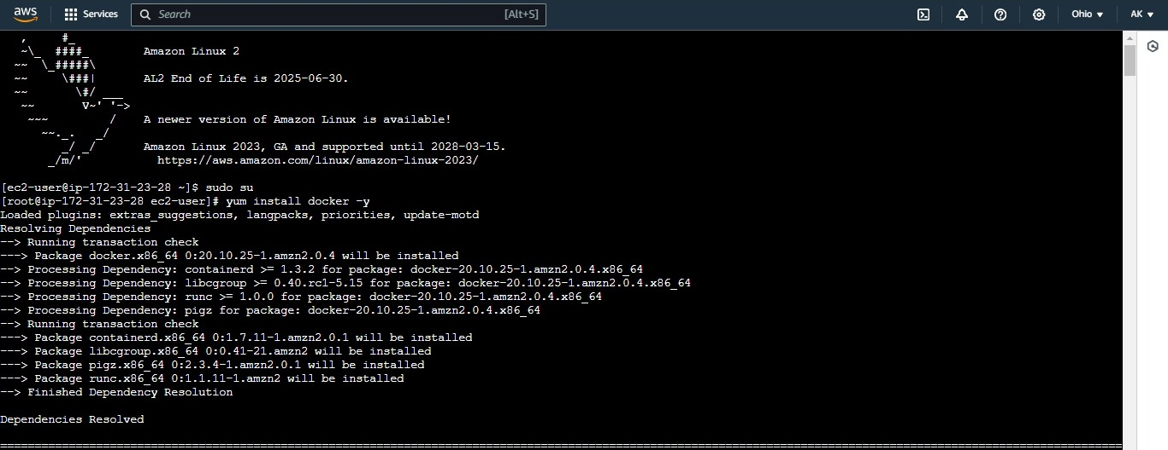

🡪after successful installation of docker, I started docker demo, for that I entered this command (docker start command),

#systemctl start docker

(I started using my docker service).

Repeat these commands in remaining servers too.

Step 2: Install kubernetes for that I downloaded kubeadm.

(From kubernetes documentation, I copied these commands and executed).

🡪By using that command, I created my kubernetes repository and kubernetes package.

🡪After executing this command, we can see my kubernetes repo in my repolist.

🡪Repeat the step 2 in remaining servers.

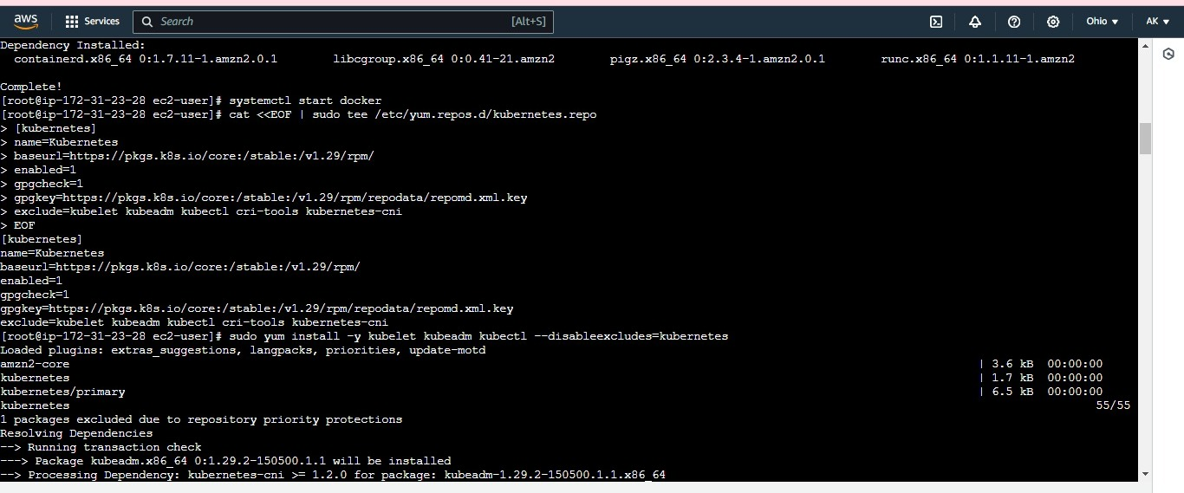

🡪Initialize kubeadm in master server (mas1) by using this command

#kubeadm init

🡪After successful initialization, we will get a configuration which we have to execute.

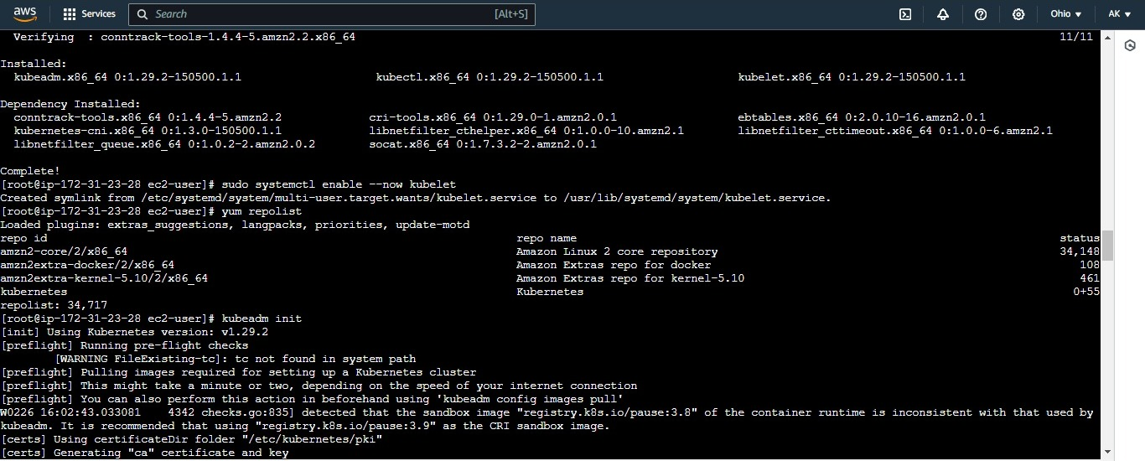

🡪Now I started using my cluster, from the configuration.

🡪From kubeadm join command copy and paste in node1 and node2. So that we can join any number of worker nodes. Later the nodes will be joined to my cluster.

🡪After successful initialization, we can check how many nodes are joined.

🡪The statuses of my nodes are not ready because they doesn’t have sufficient network in between.

🡪For that I created a network called calico network and download it.

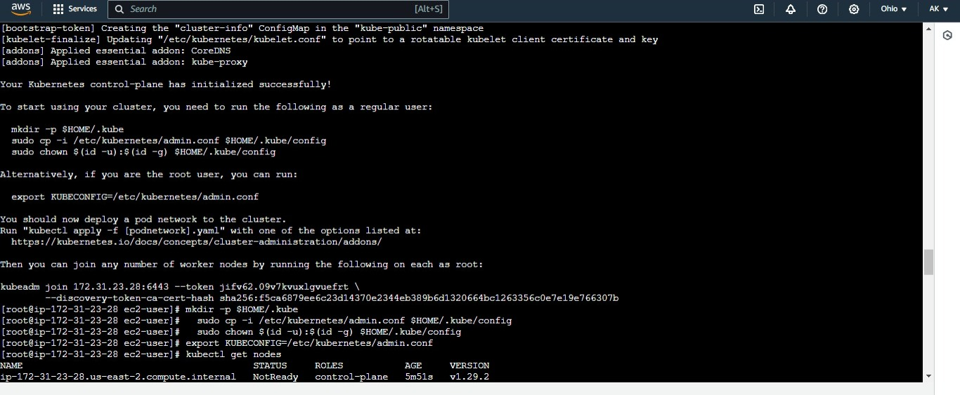

🡪Now check whether the nodes are in ready state or not.

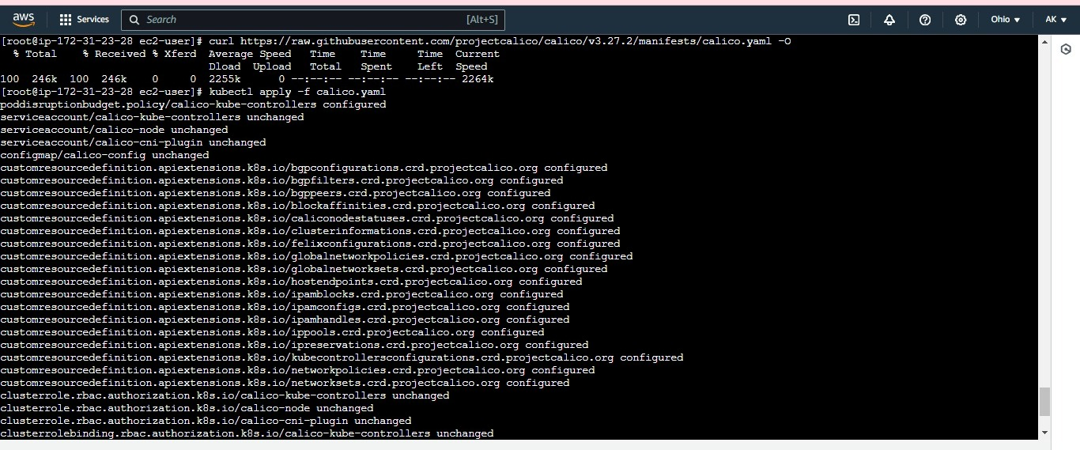

sudo yum list --showduplicates kubeadm --disableexcludes=kubernetes

From this command, we can see which version to upgrade.

sudo yum install -y kubeadm-'1.29.x-*' --disableexcludes=kubernetes

kubeadm version

sudo kubeadm upgrade plan

sudo kubeadm upgrade apply v1.29.x

🡪In the place of “x” select the version.

sudo yum install -y kubelet-'1.29.x-*' kubectl-'1.29.x-*' --disableexcludes=kubernetes

Finally, version is upgraded.

